Compile Using TI Optimizing Compiler for C6722 DSP 4-9-14
Simple Benchmark loaded into Thread #2 – file = <Install>\C Programs\TI_Compiler\BlinkFast.c
#include "KMotionDef.h"

// Benchmark 4 million loops with double precision math

main()
{
int i;
double k=0;
volatile double n;

for(;;)
{
SetBit(47);
SetBit(46);
for (i=0;i<2000000;i++) k+=i;
n+=k;
ClearBit(47);
ClearBit(46);
for (i=0;i<2000000;i++) k+=i;;
n+=k;
}
}
Determine addresses of any routines required in your program. In this case we need SetBit and ClearBit to Blink the LED. Use a simple program to determine the routine Addresses in KFLOP for the Version you have:
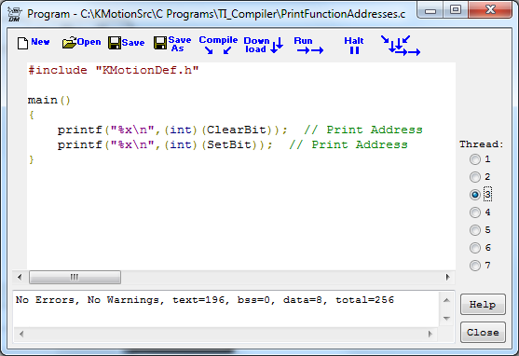
Record the Addresses from the Console:
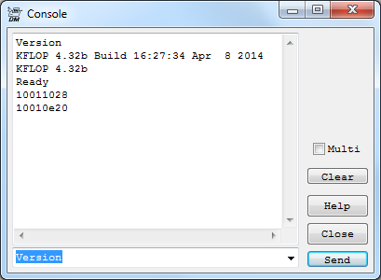

Define the function symbols and their values as shown below in the TI Linker Command file: LnkThread2.cmd. This links the Code into some remaining unused Internal DSP RAM. The 256Kbytes of high speed Internal DSP RAM resides in address range 0x10000000 – 0x1001ffff

-c
-heap 15700000
-stack 0x800
/*-lrts6701.lib */

/* LINK CMD FILE TO PUT USER PROGRAM IN SMALL SPACE AT END OF INTERNAL DSP RAM !!!!!!!!!!!!!!!!! */

/* Hard Code KFLOP Addresses */
_SetBit=0x10011028;
_ClearBit=0x10010e20;

MEMORY
{
IRAM_BOOT: o = 10000000h l = 00001000h
ENTRYPT: o = 10001000h l = 00000040h
/* IRAM: o = 10001040h l = 0001efc0h */

IRAM: o = 1001c000h l = 00004000h /* for FAST User C Programs use small leftover toward end of IRAM !!!!!!!!!!!!*/

The Batch file MakeThread2.bat can be used to Compile and Link the file BlinkFast.c into the binary file BlinkFast(2).out. Note the –o3 selects high optimization.

"C:\CCStudio_v3.1\C6000\cgtools\bin\cl6x" -k -q -al -as -i"..\..\DSP_KFLOP" -mu -ml3 -mv6710 -o3 "BlinkFast.c"
"C:\CCStudio_v3.1\C6000\cgtools\bin\cl6x" -@"c:\KMotionSrc\C Programs\TI_Compiler\Thread2.lkf"
del "c:\KMotionSrc\C Programs\TI_Compiler\BlinkFast(2).out"
rename BlinkFast.out BlinkFast(2).out

Ignore the warning regarding the C startup vector of _c_int00
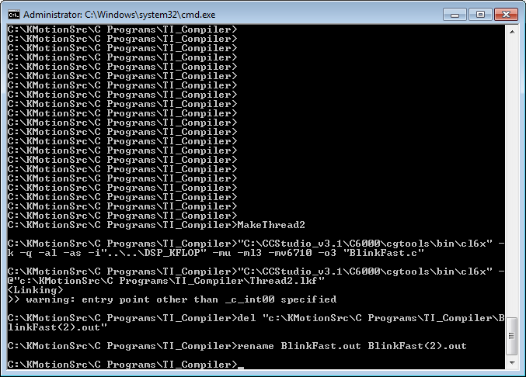

Because we created the executable code with the same name BlinkFast(2).out as the standard compiler would create for Thread#2 we can use the Download and Run Buttons to execute the code. Note: do not push compile (or save/compile/download/run) or the TI generated binary will be overwritten by the standard TCC67 binary)
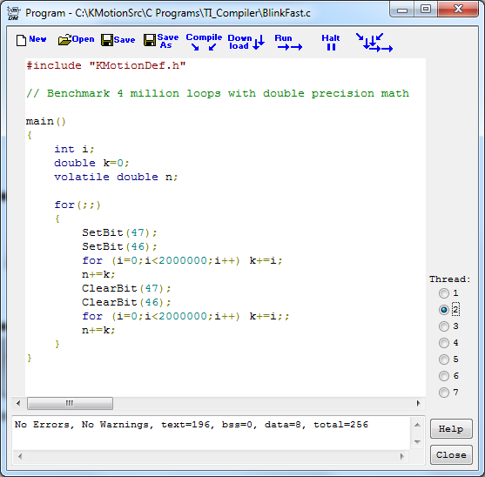
This code runs 24X faster. 24,000,000 loops per second while using only a fraction of the DSP’s time.
Each loop consists of:
- 32-bit integer count
- Integer to 64-bit double precision conversion
- 64-bit double addition
- Test
- Branch.

